Multi-Level Oil Indicator (MLOI) Test Bench User Guide

TABLE OF CONTENTS

- Scope

  - Purpose
  - Applicable Documents
  - Application

- Requirements

Personnel

Deviations

- User Guide

  - Principal Tasks
  - MLOI Test Types
  - MLOI Operating Instructions
  - Daily Level Measurement Zer
  - MLOI Pre-Pot Front Panel Definitions
  - MLOI Post Pot (ATP) Front Panel Definitions
  - MLOI Operating Instructions – Viewing Results Report File
  - Laser Calibration & Zero Detail
  - MLOI Calibration Overview
  - MLOI Operating Instructions – Menu Items

- MLOI Thery of Operation and System Overview

- Record of Revisions
1.0 Scope:

  - Purpose: The purpose of this Allen Engineering Process Specification is to provide operating instructions for the use of the Automated ATP Test Bench for the initial setting of the Switch and Resistor Assemblies and the Final Fluid Level Acceptance testing of the Allen Aircraft Products Oil Level Sensors

  - Applicable Documents: (Latest Released Revisions)

AR 260826 Elevate MLOI Hardware Design Specs
AR 250129 Elevate OLS ATP Requirements

1.3 Application: This specification is applicable when invoked on Allen Aircraft Products, Inc. assembly drawings, assembly routings or work instructions.

2.0 Requirements:

2.1 Personnel: When invoked, the procedures shall be followed by Allen Assembly personnel.

2.2 Deviations: Deviations from the procedure are not permitted unless prior approval is obtained from the Allen Engineering Department.

- User Guide

  - Principal Tasks:
MLOI Uses LabView to automate the following principal tasks:
1. Pre-Pot – Used in manual mode to set the PCB position prior to potting the sensor. Then used for preliminary screening and verification of the PCB position as reported on the Test Report “Analysis” sheet.
2. Post-Pot/ATP – This is the Acceptance Test Procedure (ATP), a PASS/FAIL evaluation of the Device Under Test (DUT) at each of the specified Level Switch Points.
3. Level Zero – Launches daily Level Zero procedure. Requires the 2.000” gage block.
4. Level Calibration – Launches annual the 5-Point Level calibration procedure. Requires a depth gage and target to measure level
5. Resistance Calibration – Launches annual the 2-Point Resistance calibration procedure. Requires 100 and 1K ohm reference resistors.

  - MLOI Test Types:
MLOI has two types of product evaluation Protocols:
- Pre-Pot Test
- Post-Pot (ATP) Test
Pre-Pot Test
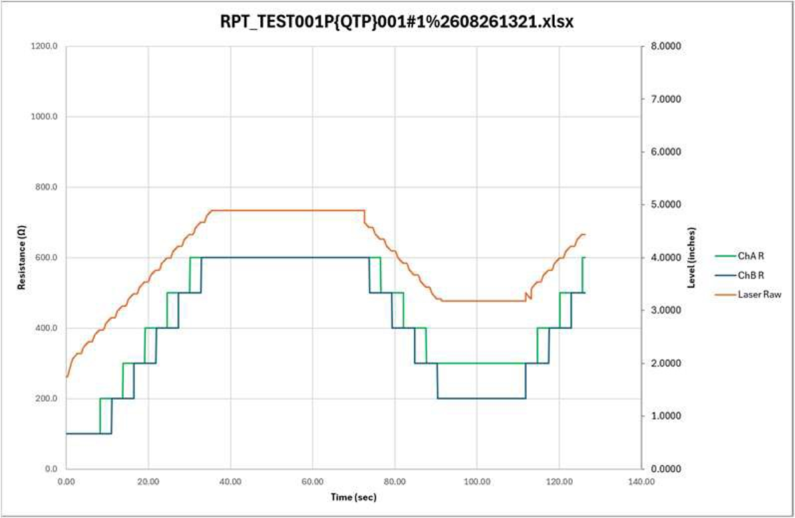
Note the addition of the ‘P’ in the Test title signifying this is a PrePot Test.
The Pre–Pot Test is pre-screening the OLS assembly and setting the PCB depth during production prior to potting the sensor. In this test, the MLOI test protocol state machine starts in MANUAL mode displaying the Level Controls. The Level can be set to any arbitrary level by adjusting the Level SP control drives which allows the user to manually determine the optimal PCB position.
When done, the user can press the START button to run the stepped level protocol where, Level and Resistance are recorded every 50ms in the Report workbook. On the Report Analysis worksheet, a macro estimates switch points to evaluate the build quality and provides an estimated adjustment for the optimal PCB set position prior to potting.

Post-Pot (ATP) Test
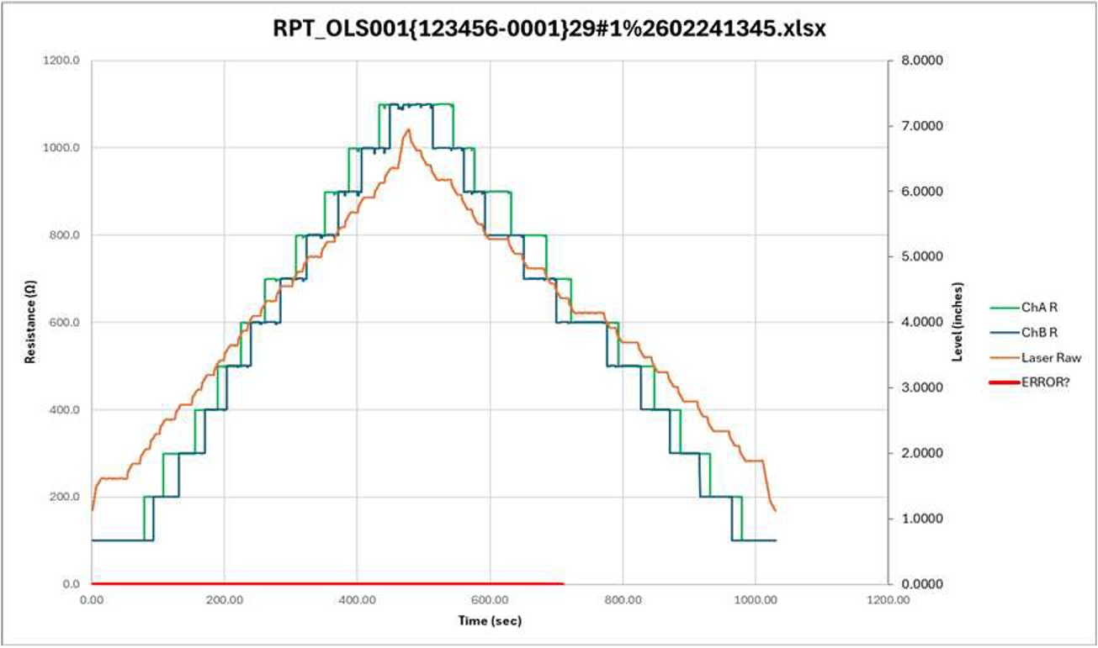
The purpose of the Post–Pot (ATP) Test is to verify OLS operation accordance with the Acceptance Test Procedure (ATP) and generate the final ATP Report. In this test, the MLOI test protocol state machine drives the level to the upper bound of the specification less a measurement uncertainty margin then pauses for programed oil settling time producing the characteristic stair-stepped Level plot. When the settling timer expires, the resistance and level are measured, tolerances evaluated and recorded. An out of tolerance measurement is indicated to the operator.
A Post-Pot Test takes about 20 minutes to run.
The following MLOI ATP Test Protocol sections describe the Post-Pot ATP Test in detail.

  - MLOI Operating Instructions:
Load DUT Dialog:
Step 1. Select Configuration File for the Product Under Test
Step 2. Enter Test Information
Step 3. Select the Type of Test to Run.
Step 4. Press OK to Start or Help to view these instructions.

  - Daily Level Measurement Zero:
If the current date is greater than the date of the last time the Level measurement was zeroed and saved in the registry file, the user will be prompted to perform a Level Measurement zero.
The steps are as follows:
- Prompt user to Zero the Laser
Measurement once the laser is
online.

- Prompt user to place the gage
block on the datum reference
plane.

- Ensure that the gage block is flat
across the top plate and the red
laser beam is shining on the gage
block.

- Normally the operator would save
the new Level Zero at this point or
contact Test Engineer if the New
and old Zero’s are significantly
different.

  - MLOI Pre-Pot Front Panel Definitions:
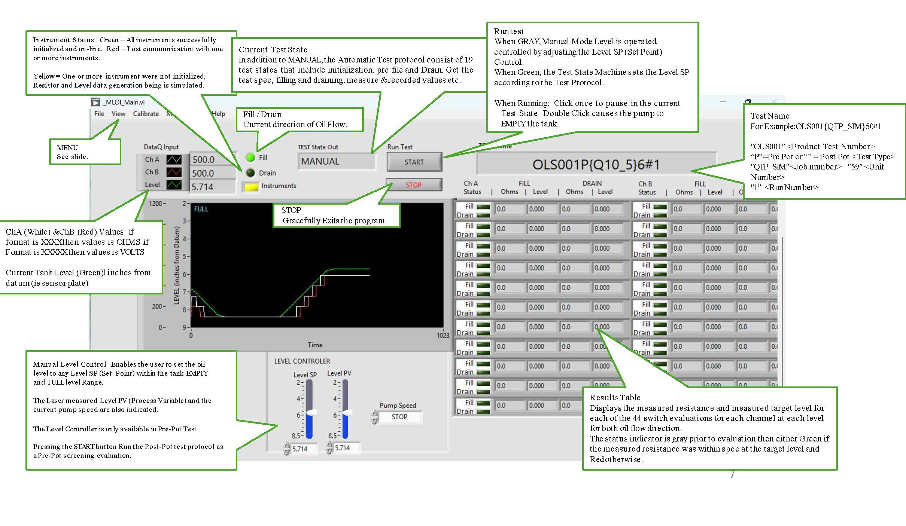

  - MLOI Post Pot (ATP) Front Panel Definitions:

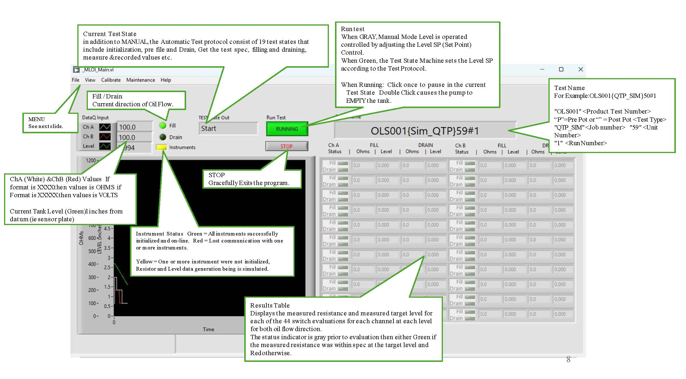

  - MLOI Operating Instructions – Viewing Results Report File:

  - Laser Calibration & Zero Detail:

  - MLOI Calibration Overview:

  - MLOI Operating Instructions – Menu Items

- MLOI Thery of Operation and System Overview:

- Record of Revisions:

Revision History
Rev. | ECO # | Date

